ON-DEMAND CAR WASH

LOW LEVEL DESIGN (LLD)



*A1A CARWASH*

**SUBMITTED BY:**

KORADA KAVYA AMRUTHA

# TABLE CONTENTS

|  |  |  |
| --- | --- | --- |
| Sl. No. | Title | Page No. |
| 1 | Introduction | 4 |
|  | 1.1. Document Purpose | 4 |
|  | 1.2. Problem Statement | 4 |
|  | 1.3. Intended Audience | 4 |
|  | 1.4. Project Background | 5 |
|  | 1.5. Project Objective | 5 |
|  | 1.6. Project Scope | 5 |
|  |  |  |
| 2 | Design Pattern | 6 |
|  | 2.1. Overview | 6 |
|  | 2.2. System Design | 6 |
|  | 2.2.1. Customer Management Flow | 6 |
|  | 2.2.2. Car washer Management Flow | 6 |
|  | 2.2.3. Admin Management Flow | 6 |
|  | 2.3. Use case diagram | 7 |
|  | 2.4. Activity diagram | 10 |
|  | 2.5. Sequence diagram | 14 |
|  | 2.6. Database diagram | 16 |

1. **INTRODUCTION**

The application follows the Green Wash process by which we can save gallons of water which is being used to clean the cars. Our application is basically, the interface between the retailer (i.e., the Car washer) and the Customer (i.e., the one who needs to wash the car). By using this application, the customer can get its car washed wherever at its convenience. Whether it’s the home, salon, office or any other place, the car wash is just few taps away if the customer uses this application. All the customer needs to do is enter their car details, location, and payment details. This application also contains various packages and add-ons and promo codes. One of the best parts of this application is the customer can also schedule future car wash and give review and ratings to the retailer.

For the following the software requirements are given below

Frontend : Angular

Backend : ASP.Net Core with WEBAPI

Database : SQL Server

## Document purpose:

The purpose of this document is to provide the customers the car wash service in their fingertips which can save their time by not making them wait at long queues or going to different car wash centers. This application will allow users to select their packages as per their convenience and will also allow the users for future scheduling and choose different packages and add-on’s as per the customer convenience.

## Problem Statement:

The car was service had become common and widely spread among the world nowadays. But the car owners are finding the car wash process as a wastage of time as they had to wait in a queue for their required service. Here location also plays a major role as for the customers who visited to outstation or visited to other places and may wish for a car wash service. However, they won’t be able to know any car wash center near them. Thus, it is difficult for customers to get a car wash service as they are not familiar with that area. Also due to these car wash services gallons of water is getting used and most get wasted due to the excessive use of it as the car requires more water to get cleaned.

## Intended Audience:

This document is intended as a reference for the following roles and stakeholders who are interested in the On Demand Carwash application.

|  |  |
| --- | --- |
| **ROLE** | **NATURE OF APPLICATION USER** |
| Customer | The person to whom the service is directly provided to. |
| Car Washer | The person from whom the service is provided. |
| Admin | The person who would be responsible for smooth functioning of the system. |

## Project Background:

Car wash is a service provided by the retailer i.e., the car washers which is used to clean the exterior or the interior of the vehicles. There are different services for different car models and as per the customer requirements. Usually, people had to pay for the car wash service and their cars are washed by the workers at the car. The needs for the car wash service are increased every year thus, the car wash service is being increased every year in both short-term and long-term. Nowadays, the car wash service can be found anywhere. Therefore, the car wash service is evolving and is using more advanced, eco-friendly, and convenient equipment.

The main motivation of developing this project is to allow users make appointment of the car washer online. The user has to just select and fill in some details in order to make an appointment or schedule the car wash online. The user has to select and fill in some details in order to schedule its appointment successfully. Once done with the appointment the car washer will get a request and by accepting that request it will get confirmed and the other process will be processed. The only difference here will be that the customer doesn’t have to go to the centre instead the car washer will come to the location for the booked service.

## Project Objective:

The main objective of this project is to develop an application that will be able to book appointments for the customers. This application will basically make it much easier for car owners as this application will allow users to book their appointments as per their convenience. Here, the application directly connects the customer to the car washer so that, they (the customer) can send the wash request to the car washer and schedule their appointment as per their convenience.

## Project Scope:

The scope of this project is to develop an application which is an appointment scheduling system. The customer will be able to schedule their appointment for car wash service using this application at anytime and anywhere. The customer will also be able to check the availability of the car wash center as per their own location.

# DESIGN PATTERN

The design pattern basically defines different patterns as per the problem occurred. As each pattern describes a problem that is occurred again and again in the application and then describes the core of the problems. The design patterns are the best solution for the reoccurring problems in the application programming. As it provides a universal standard of solving the problems. And it is also responsible for the design pattern in other areas, including GUIs.

## 2. Overview:

The application has three phases, and these phases are: - admin part, car washer part and the customer part. Here, these three phases are described with different diagrams, those will be explained later on the document. Besides, the development process is briefly explained through the code of the project.

## System Design:

The system is separated into front-end and back-end. Besides, there are 3 different flows in the system framework which is customer management flow, car washer management flow and the admin management flow.

* + 1. Customer Management Flow:

The customer management flow starts when the user logins to the applications and provides details of its own as per the requirement. After providing certain required details the customer schedules the appointment for the car washing as per its convenience. The customer is also provided with various packages and add-on and promo-codes. After booking the appointment the customer waits for the acceptance of its order and one accepted and the work is done, they have to pay for the service and give review and ratings to the car washer.

* + 1. Car washer Management flow:

The car washer management flow starts when the appointment is booked by the customer, that is when the car washer logins to the application it goes to its home page and there the wash request option is there and when they go to that option the wash requests are displayed on their screen and once the request is accepted the car washer have to visit to the location of the customer as per accepted request. And once the service is done the car washer receives the payments and gets the feedback from the customer as per the customer.

* + 1. Admin Management Flow:

The admin management flow starts when it logins to the application basically when the admin logins to the application it goes to its home page. The home page of the admin is totally different from the customer and the car washer as it has the access to both the user details and the customers details,

the admin does the management part it includes all the management i.e., user management (customer and car washer), car management, service plan management, add-on management, promo-code management, order management, report management. Thus, it manages each and everything of the application and everything stored in the database is accessible to the admin.

## Use case diagram:

A use case represents a scenario which describes how user interacts with the system to perform a task. This section has included use case diagram and use case description. Besides, the relationships between the user in achieving goal is also described in the use case description. Here three use case diagrams are represented as the application has three phases i.e., the customer phase, the car washer phase and the admin phase

* + 1. Use case diagram for Customer:

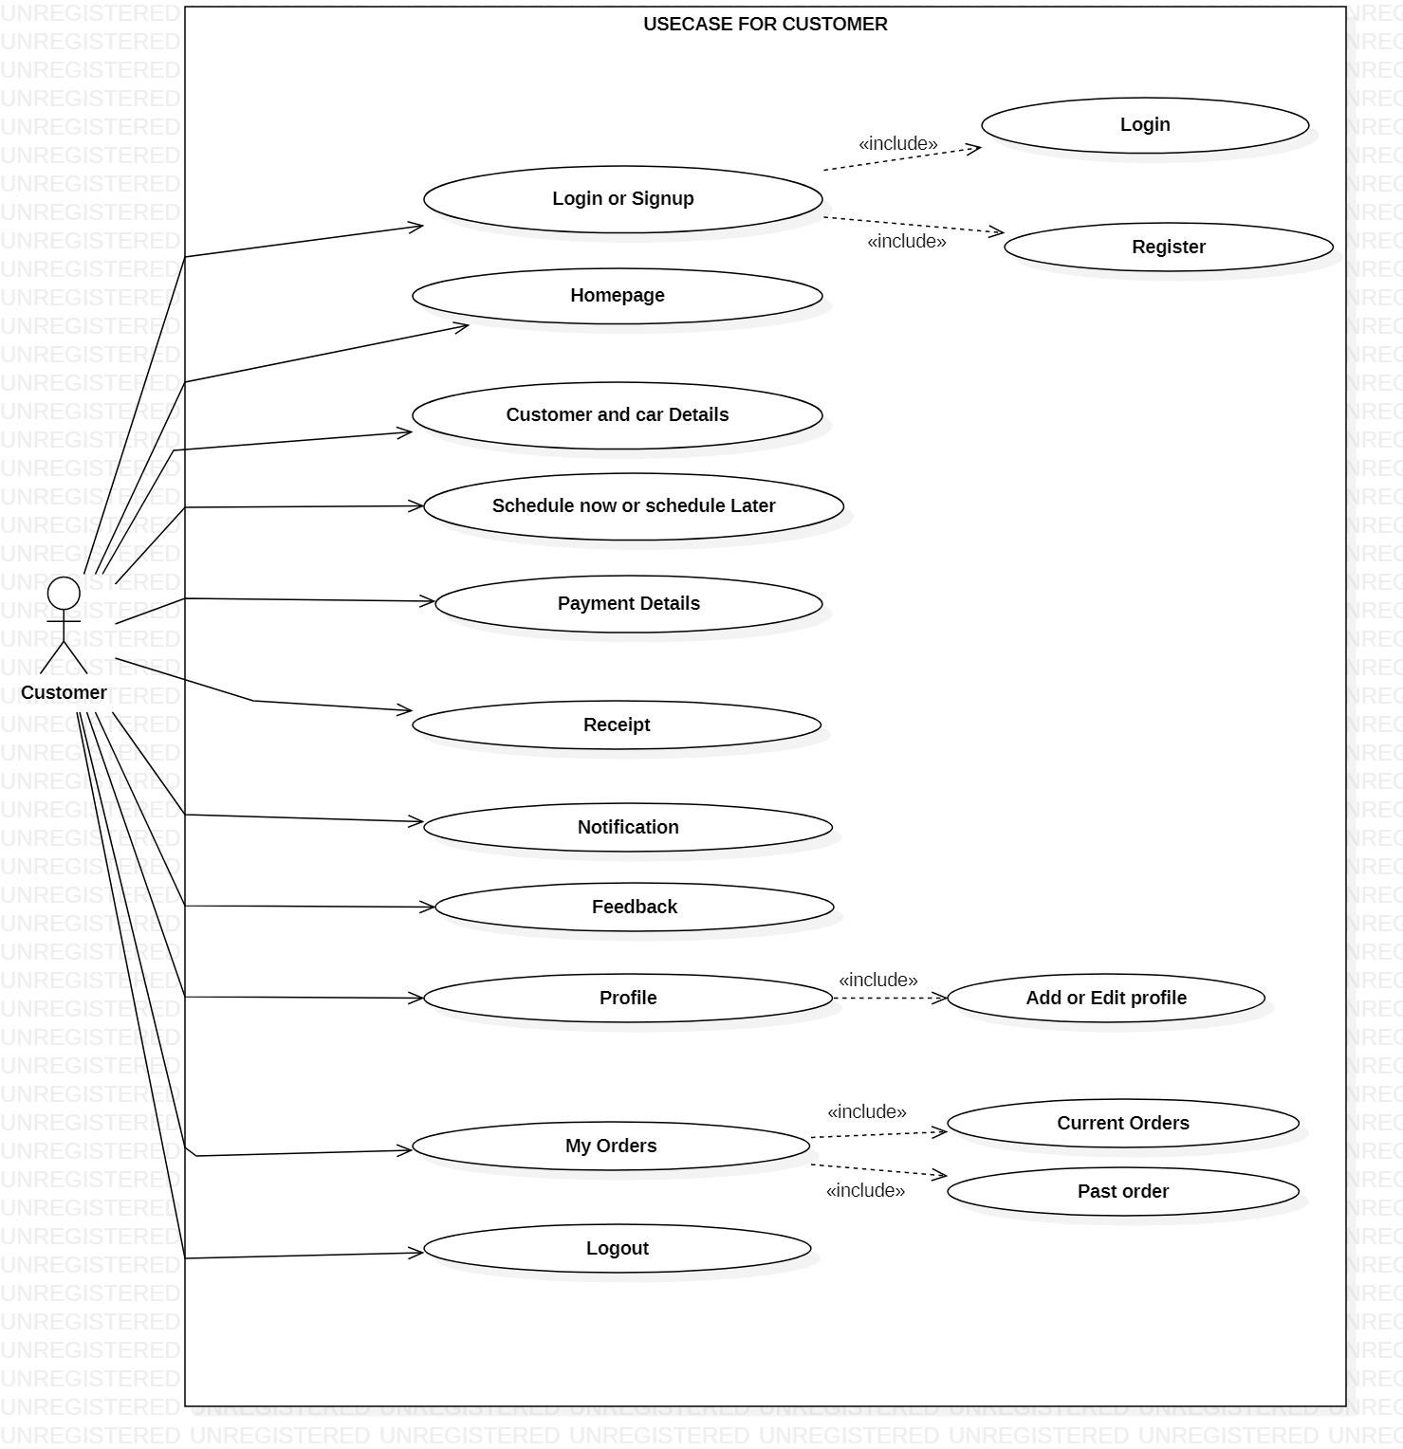

* + 1. Use case Diagram for Car washer:

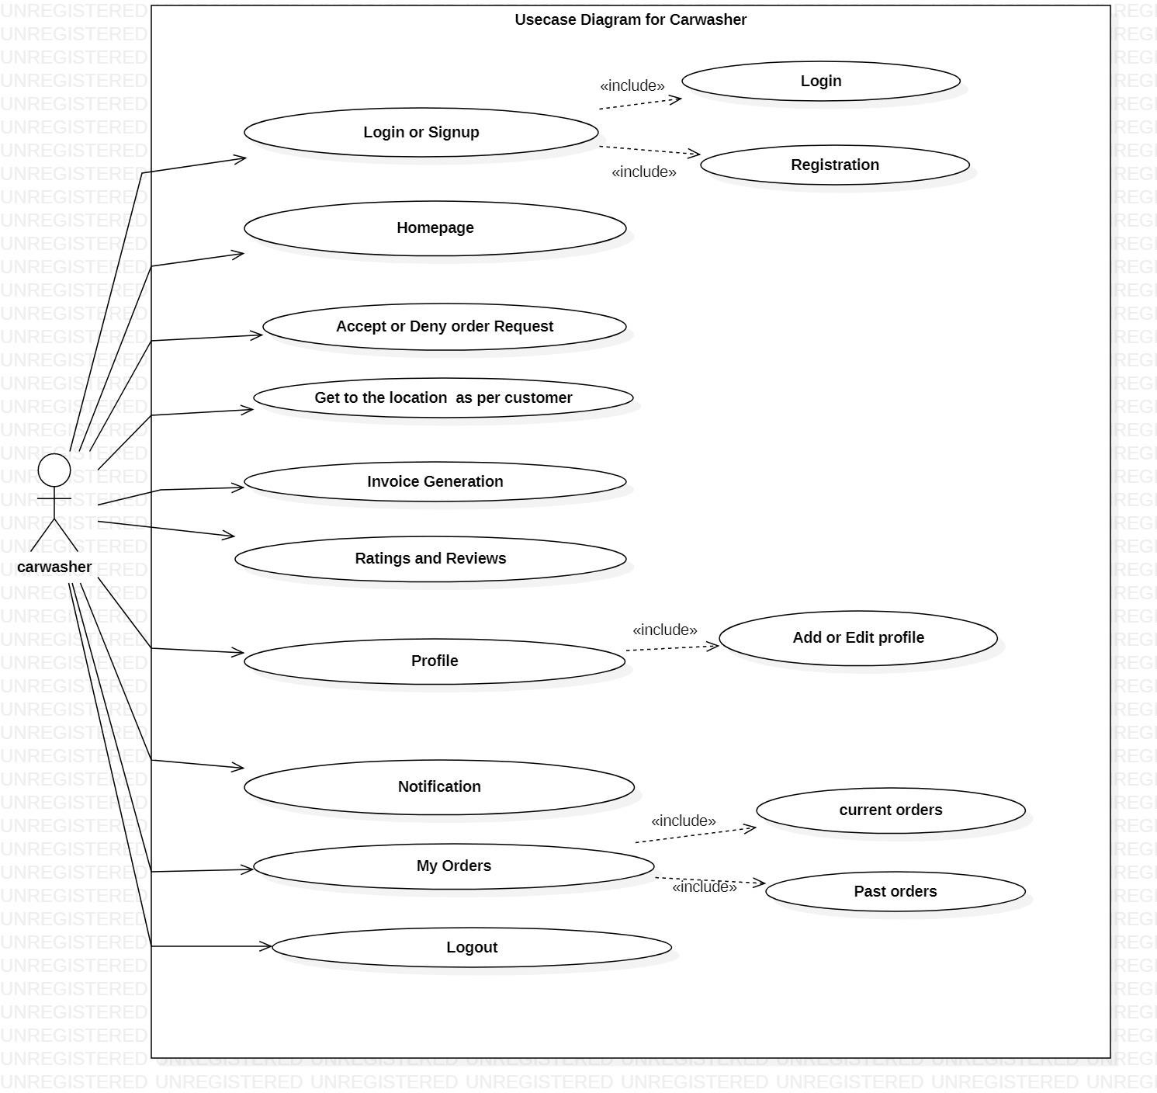

* + 1. Use case diagram for Admin:

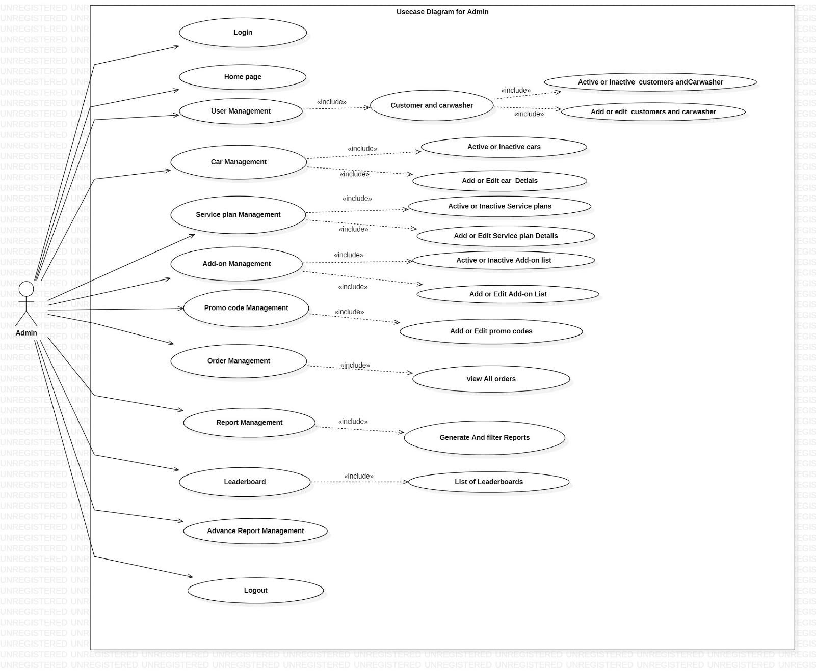

## Activity Diagram:

* + 1. Activity Diagram for Login:

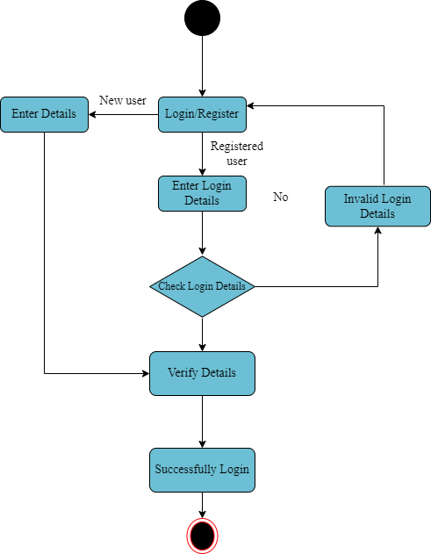

* + 1. Activity Diagram for Customer:

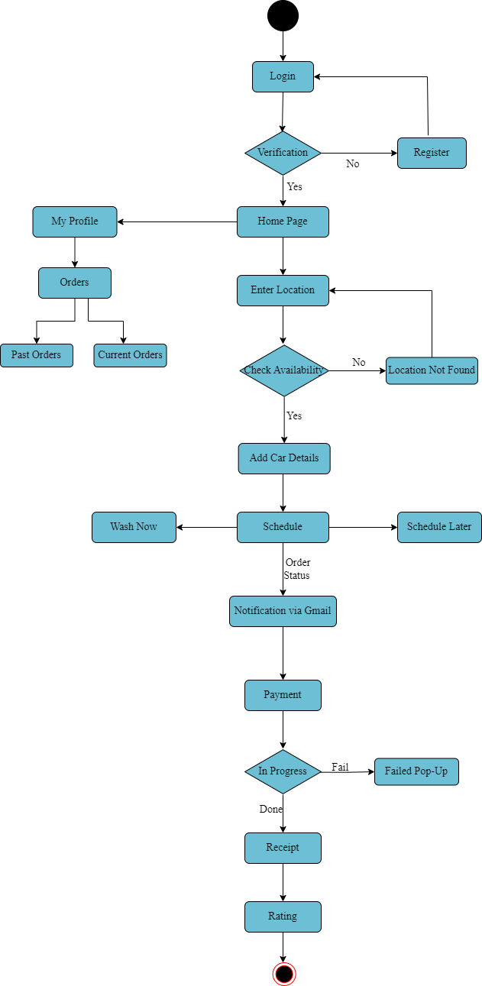

* + 1. Activity Diagram for Car washer:

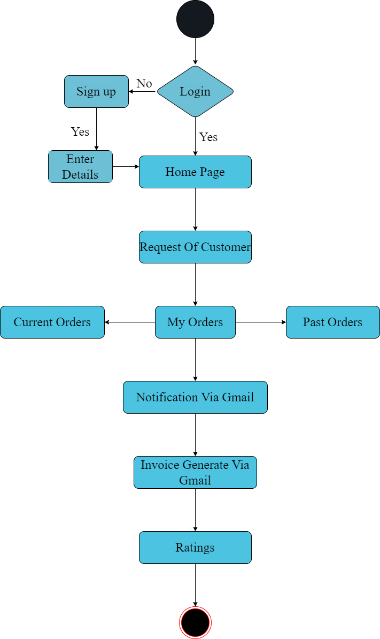

* + 1. Activity Diagram for Admin:

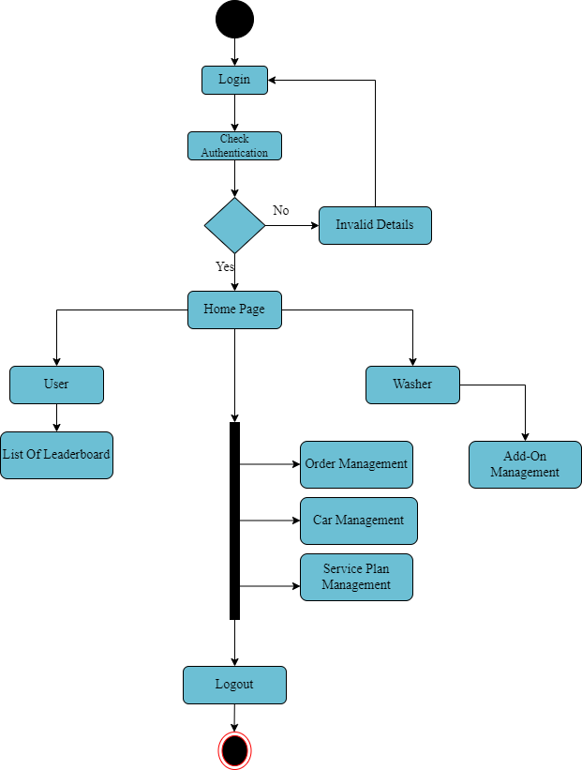

## Sequence Diagram:

* + 1. Sequence diagram for login:

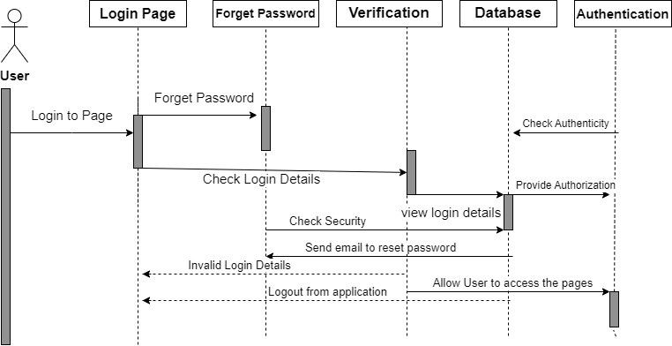

* + 1. Sequence diagram for Admin:

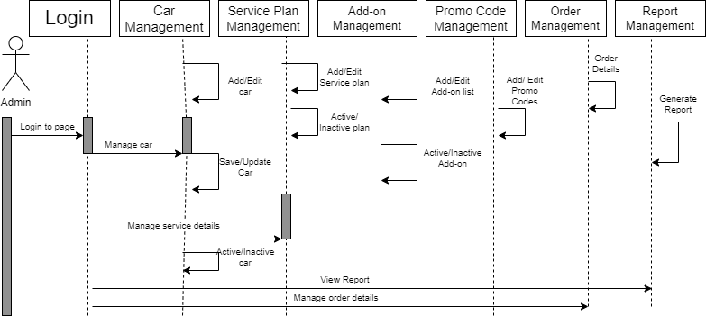

* + 1. Sequence diagram for Retailer:

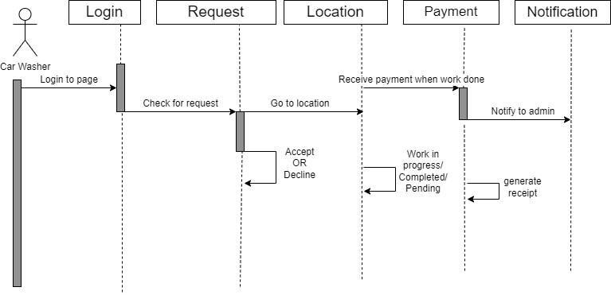

* + 1. Sequence diagram for Customer:

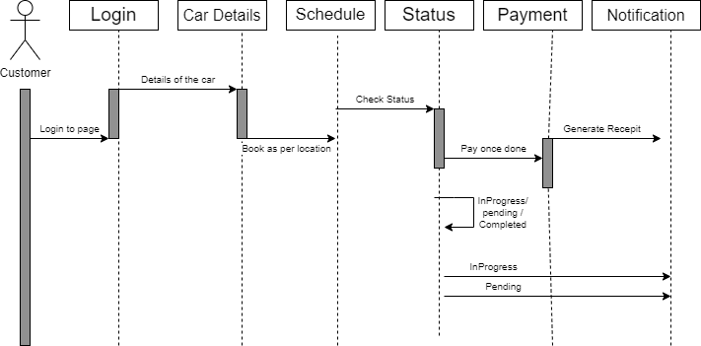

* 1. **Database Diagram:**

